Successive Differentiation

Find the nth derivative of the following functions:
1. 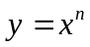.
2. y = 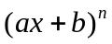.
3. 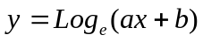.
4. 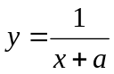
5. 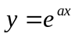.
6. 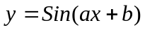.
7. 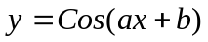.
8. 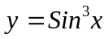.
9. If 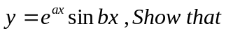 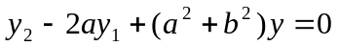
10. If 